1. The Core Framework: The CIA Triad
The CIA Triad is the model used to guide policies for information security within an organization. All security controls generally address one or more of these three principles.
- Confidentiality (Privacy):
  - Goal: preventing sensitive information from reaching the wrong people.
  - Measures: Encryption, Access Control Lists (ACLs), Two-Factor Authentication (2FA).
  - Example: Only HR managers can view employee salary data.
- Integrity (Trustworthiness):
  - Goal: Ensuring data is consistent, accurate, and trustworthy over its entire lifecycle. It must not be altered by unauthorized people.
  - Measures: Hashing (checksums), Digital Signatures, Version Control.
  - Example: Ensuring a downloaded file matches the original source exactly and hasn't been tampered with.
- Availability (Uptime):
  - Goal: Ensuring that authorized parties are able to access the information when needed.
  - Measures: Redundancy (backups), RAID, Load Balancing, Disaster Recovery plans.
  - Example: A banking website handling high traffic without crashing.

2. Common Threat Types
These are specific methods adversaries use to compromise systems.
Phishing
- Definition: A deceptive practice where attackers send fraudulent communications (usually emails) that appear to come from a reputable source.
- Goal: To steal sensitive data like credit card numbers or login info.
- Key Indicator: Urgency ("Click here now or your account will be locked").
Malware (Malicious Software)
- Definition: An umbrella term for any software designed to cause damage to a computer, server, or network.
- Types: Viruses, Worms, Trojans, Spyware.
- Mechanism: It often requires user action (clicking a link) to install, though worms can self-replicate across networks.
DDoS (Distributed Denial of Service)
- Definition: An attempt to make an online service unavailable by overwhelming it with traffic from multiple sources.
- Mechanism: Attackers use a "botnet" (a network of infected computers) to flood the target server.
- Analogy: A traffic jam clogging a highway, preventing regular cars from arriving at their destination.
SQL Injection (SQLi)
- Definition: An injection attack that makes it possible to execute malicious SQL statements that control a web application's database server.
- Mechanism: An attacker enters code into a standard input field (like a username box) that tricks the database into revealing hidden data.
- Example Input: admin' -- (This might trick a database into logging in without a password).
Brute Force
- Definition: A trial-and-error method used to obtain information such as a user password or personal identification number (PIN).
- Mechanism: Automated software generates a large number of consecutive guesses to find the correct credential.
- Defense: Account lockouts after 3 failed attempts.
Ransomware
- Definition: A type of malware that encrypts a victim's files. The attacker then demands a ransom from the victim to restore access to the data.
- Impact: Can cripple hospitals, governments, and large corporations.
- Note: Paying the ransom does not guarantee data recovery.

3. Attack Vectors
An attack vector is the path or means by which a hacker gains access to a computer or network server.
Social Engineering (Hacking Humans)
- Concept: Manipulating people into giving up confidential information. This relies on human psychology (fear, curiosity, helpfulness) rather than technical exploits.
- Example: "Pretexting," where an attacker pretends to be IT support needing your password to "fix a glitch."
Wireless Attacks
- Concept: Exploiting vulnerabilities in wireless networks (Wi-Fi).
- Rogue Access Point: An attacker sets up a fake Wi-Fi spot (e.g., "Free Airport Wi-Fi") to intercept data flowing through it.
- Packet Sniffing: Using software to capture data packets flying through the air on unsecured networks.
Insider Threats
- Concept: A security risk that originates from within the targeted organization.
- Types:
  - Malicious: A disgruntled employee intentionally leaking data.
  - Accidental: An employee losing a laptop or falling for a phishing scam.
- Why it's dangerous: Insiders already have authorized access, bypassing firewalls.

Lab Environment Setup
1. Install the VirualBox
The VirualBox is the software that allows you to run virtual machines (VMs) on your physical computer.
- Download: Go to the VirtualBox website and download the "Platform Package" for your OS (Windows, macOS, or Linux).
- 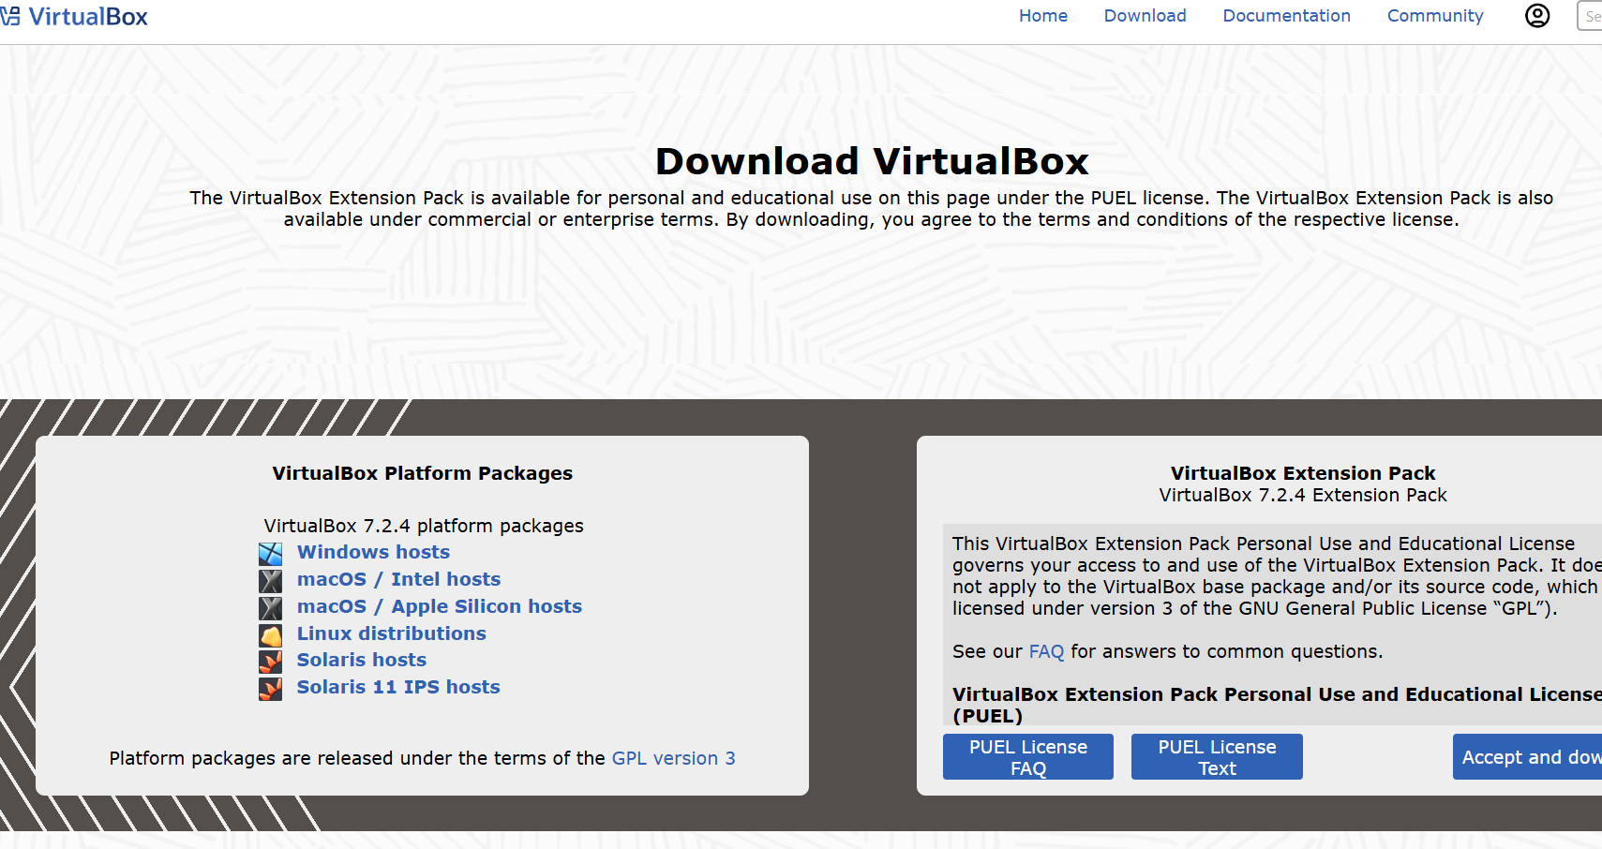
- Install: Run the installer and follow the default prompts.
- Extension Pack: It is highly recommended to also download and install the "VirtualBox Extension Pack" from the same page to ensure better USB and hardware support.
2. Install Kali Linux (Attacker Machine)
Kali Linux is the industry standard for penetration testing. The easiest method is to use a pre-built VirtualBox image.
- Download: Visit Kali.org/get-kali.
- Select: Choose the Virtual Machines (Pre-built) option, not the "Installer Images". Download the VirtualBox version (64-bit is standard).
- 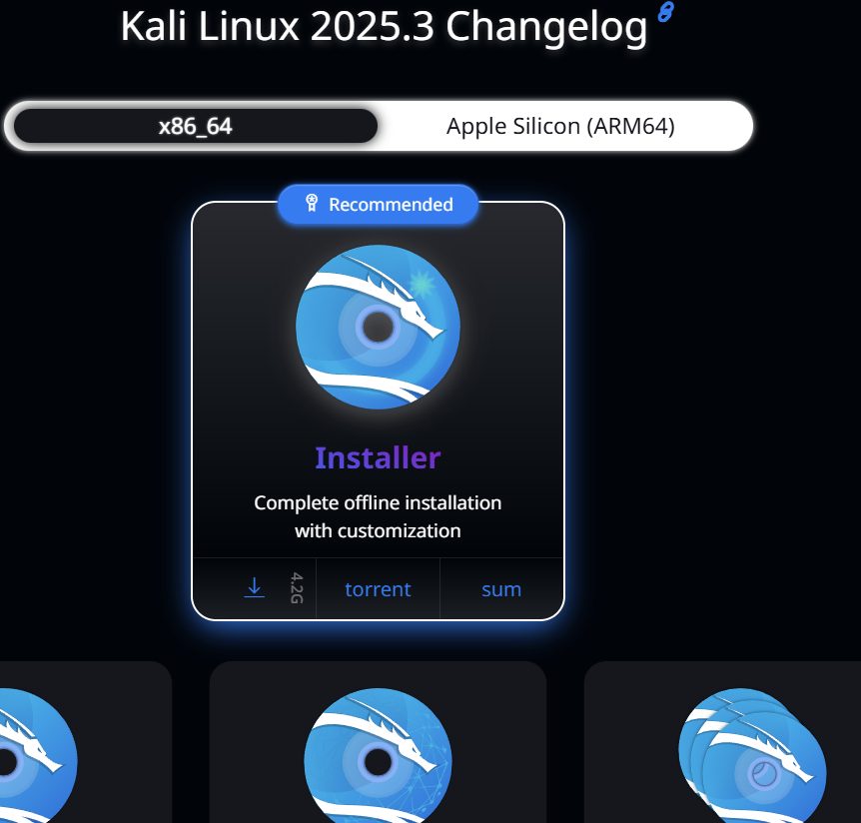
- Import:
  - Extract the downloaded .7z file (you may need 7-Zip).
  - Open VirtualBox and double-click the .vbox file inside the extracted folder. It will automatically add the machine to your list.
- Credentials: The default login is typically username: kali / password: kali.
3. Install Metasploitable 2 (Target Machine)
Metasploitable 2 is an intentionally vulnerable Linux virtual machine. Note: It includes DVWA pre-installed, so this covers both requirements.
- Download: Go to the SourceForge Metasploitable page and download the zip file.
- Extract: Unzip the file to a folder where you want to keep your VMs.
- Create VM in VirtualBox:
  - Click New in VirtualBox.
  - Name: "Metasploitable 2".
  - Type: Linux. Version: Ubuntu (64-bit).
  - Hardware: Give it 1-2 CPUs and 1024 MB RAM.
  - Hard Disk: Select "Use an Existing Virtual Hard Disk File". Click the folder icon $\to$ Add $\to$ Navigate to your extracted Metasploitable folder $\to$ Select the Metasploitable.vmdk file.
- Credentials: The default login is username: msfadmin / password: msfadmin.
4. Configure the Private Lab Network (Host-Only)
This is the most critical step. You must isolate these machines so the vulnerable target is not exposed to the internet.
- Create the Network:
  - In VirtualBox, go to File $\to$ Tools $\to$ Network Manager.
  - Click Create to make a new "Host-Only Ethernet Adapter" (usually named vboxnet0).
  - Ensure the "DHCP Server" box is checked/enabled so your VMs get IP addresses automatically.
- Configure Kali:
  - Right-click your Kali VM $\to$ Settings $\to$ Network.
  - Change "Attached to" from "NAT" to Host-Only Adapter.
  - Select the adapter you just created (vboxnet0).
- Configure Metasploitable:
  - Right-click your Metasploitable VM $\to$ Settings $\to$ Network.
  - Change "Attached to" from "NAT" to Host-Only Adapter.
  - Select the same adapter (vboxnet0).
5. Verification
- Start both VMs.
- On Metasploitable, login and type ifconfig. Note the IP address (e.g., 192.168.56.101).
- On Kali, open a terminal and ping [Metasploitable_IP]. If it replies, your lab is ready.
- Access DVWA: Open the Firefox browser inside Kali and type the Metasploitable IP into the address bar to access the web vulnerabilities.
Linux Fundamentals
Goal: 90% of servers run Linux. You must be comfortable working without a mouse (GUI).
- Navigation: cd (change directory), ls -la (list all files), pwd (print working directory).
- Permissions: Understanding rwx (read, write, execute).
  - chmod 777 (unsafe, full permissions).
  - chown (changing file ownership).
- Package Management: Installing tools using sudo apt update && sudo apt install [tool_name].
- Process Management: ps aux (view running processes), kill (stop processes), grep (search text).
Phase 3: Networking Basics
Goal: You cannot hack a network if you don't understand how data moves through it.
- The Models:
  - OSI Model: Memorize the 7 layers (Physical to Application). Understand that switches work at Layer 2 and Routers at Layer 3.
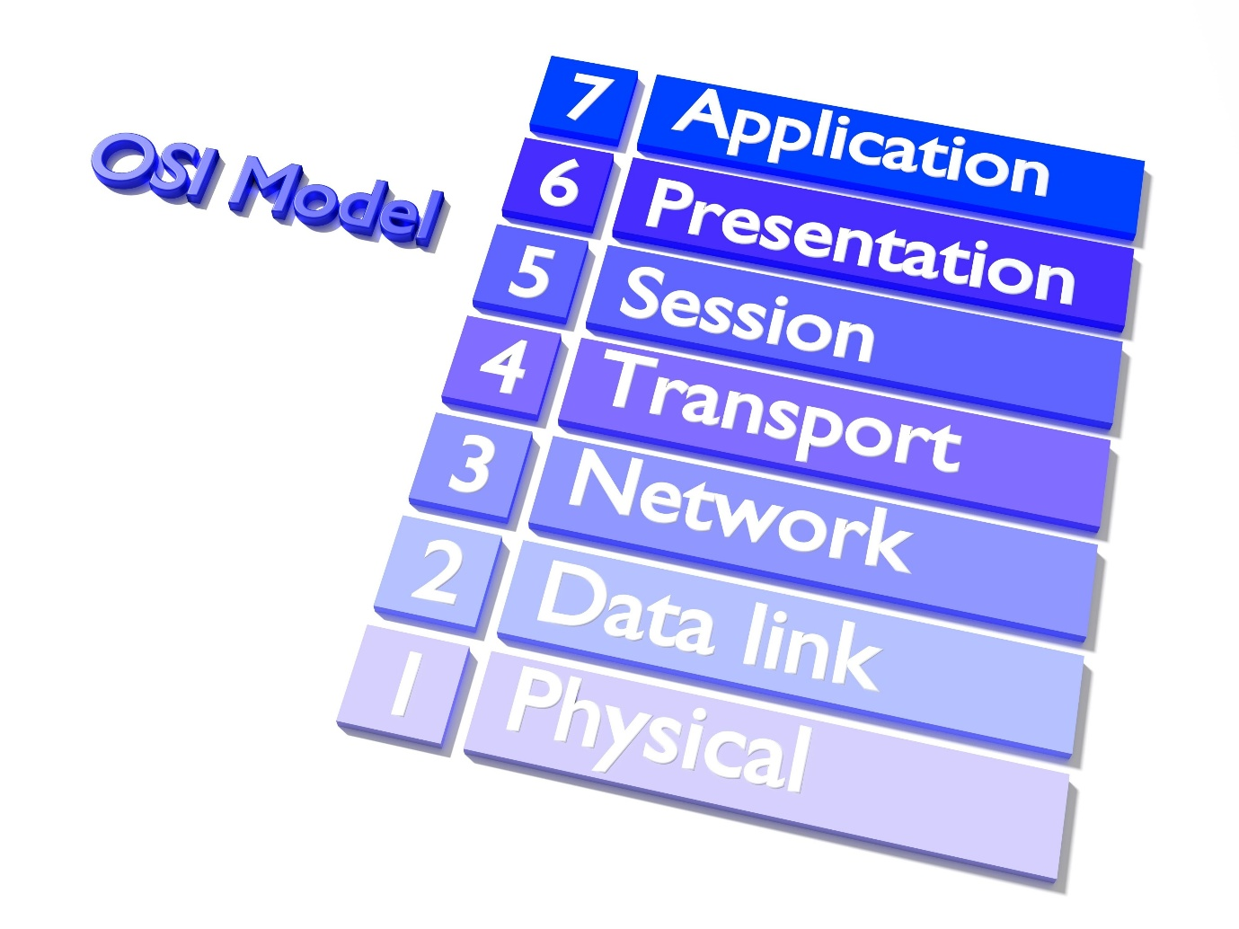
Shutterstock
* **TCP/IP:** The practical model used for the internet.
- Protocols:
  - DNS: How google.com becomes 142.250.x.x.
  - HTTP vs HTTPS: Clear text vs. encrypted web traffic.
  - Three-Way Handshake: (SYN, SYN-ACK, ACK)—critical for understanding scanning and DoS attacks.
- IP Addressing:
  - IPv4 vs IPv6.
  - Subnetting: Calculating Network ID and Broadcast IP.
  - NAT (Network Address Translation): How private IPs talk to the public internet.
Phase 4: Cryptography Basics
Goal: Understand how data is protected and verified.
- Encryption Types:
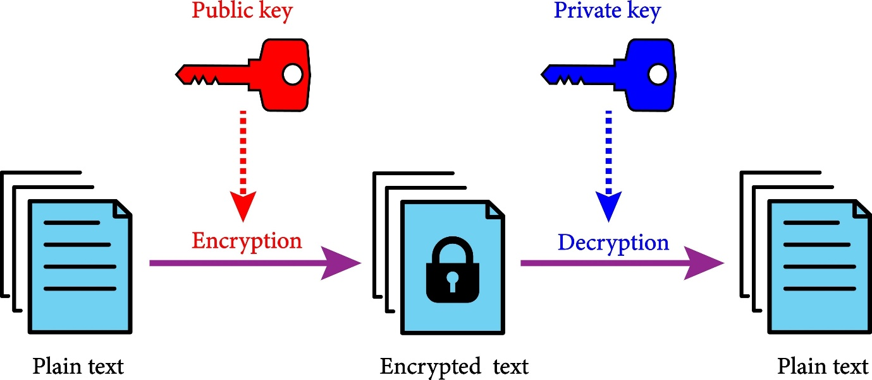
Shutterstock
* **Symmetric:** Same key for lock and unlock (AES, DES). Faster, but key sharing is risky.
* **Asymmetric:** Public/Private key pairs (RSA, ECC). Slower, but safer for initial connections.
- Hashing: One-way functions used for password storage (MD5, SHA-256). You cannot "decrypt" a hash; you can only "crack" it by guessing.
- PKI (Public Key Infrastructure): How SSL/TLS certificates work to create the "Green Padlock" in browsers.
Phase 5: The Essential Toolset
Goal: Learn the "Hacker's Swiss Army Knife."
Tool | Category | Usage
Nmap | Scanning | Finding live hosts and open ports on a network.
Wireshark | Sniffing | Analyzing packet traffic in real-time.
Burp Suite | Web Proxy | Intercepting and modifying HTTP requests (essential for web hacking).
Netcat | Networking | Reading/writing data across network connections (often used for reverse shells).
Metasploit | Exploitation | A framework for executing exploit code against targets.

2.Install Burpsuite pro
BurpSuite Professional Installation – Task Summary
The task involved installing and configuring BurpSuite Professional, a widely used web application security testing tool, on Kali Linux. I downloaded the BurpSuite Pro .jar file from the official PortSwigger website, moved it to the /opt directory, and provided the required execution permissions. I then installed Java JDK to ensure the application could run properly. After setup, I launched BurpSuite Professional through the terminal and verified that it opened successfully. During the process, I encountered a permission error when trying to delete a write-protected file, which I resolved using the sudo rm -f command. The installation was completed successfully, and BurpSuite Pro is now ready for use in future web security testing tasks for the internship.
Commands :- git clone “url”
Cd /opt , chmod +x install.sh , ./install.sh
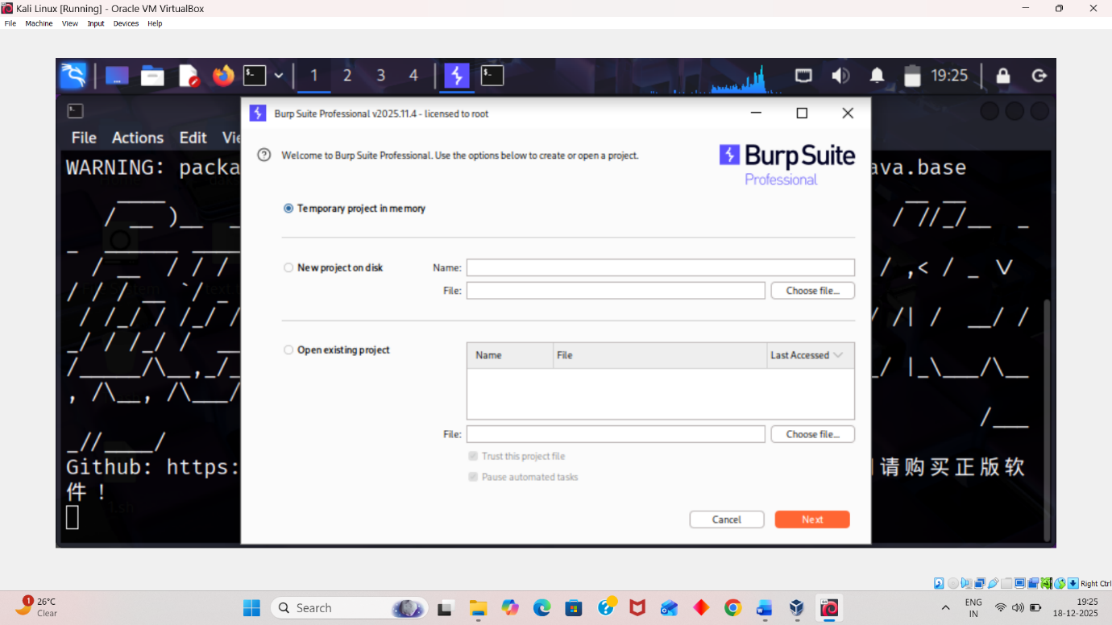
BurpSuite Configuration & CA Certificate – Summary
I configured BurpSuite’s proxy on 127.0.0.1:8080 and set my browser to use the same proxy. Then I downloaded and installed the Burp CA Certificate from http://burp to enable HTTPS interception. After adding the certificate, BurpSuite successfully captured and decrypted browser traffic for testing.
